Visual Literacy
Name
Institution
Date

Visual Literacy
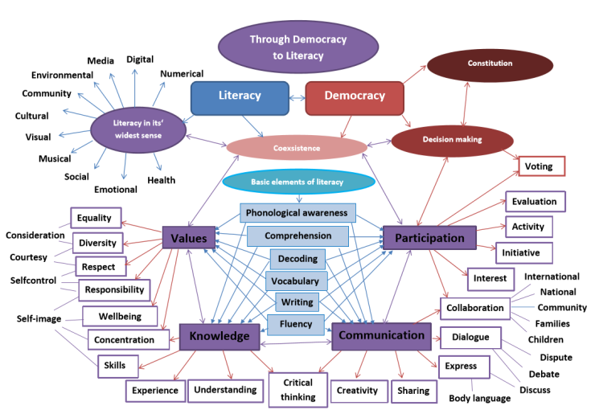
The ability to identify and comprehend ideas disseminated through visible images or actions is referred to as visual literacy. According to Matusiak, Heinbach, Harper &Bovee, (2019), the process requires the examiner to have a sense of curiosity and analytical skills to scrutinize the provided visual images keenly. Based on the above provided visual aid, the learner can utilize the provided media and art to interpret the contribution of visual literacy to people’s lives, including improved decision making, participation, and development of knowledge (Arneson, &Offerdahl, 2018). Additionally, a learner can interrelate the images from the above visual aid and provide a meaningful interpretation relating to the significance of democracy in impacting literacy into the learner's mind.
Importantly, visual literacy gives an in-depth connection with various types of images and texts while upholding analytical interpretation of their hidden meaning and representations. It worth noting that non-verbal communicator depends entirely on visual literacy to convey and communicate their thoughts (Kędra, 2018). The above image on the contribution of democracy to people's literacy gives a comprehensive interconnection between the various pictures and texts. Precisely, each component is accompanied by subsections as well as a pointer for indicating their connection. As a result, a dumb person can learn quickly using the image in addition to identifying the relationship between components and its subsections.
A leaner that is provided with both visual literacy and text can interpret and comprehend information more quickly than the one using either text or image alone. Notably, readers tend to create mirage illusion of the information which has no visual aids to have a clear view of a writer's point of view (Arneson, &Offerdahl, 2018). Based on the setting of the image above, a reader will find it easy to identify the benefits of deliberative democracy, including an understanding of the constitution, improved personal values, knowledge, communication, and participation. Additionally, the reader can easily interconnect the outcome of the components with their origin.
Visual literacy provides a reader with a structured breakdown of a particular topic, which will aid in coming with a well-organized essay or discussion (Kędra, 2018). Precisely, a learner intending to provide a written critique from the above image will not encounter difficulties while formulating the information to include in various paragraphs (Arneson, &Offerdahl, 2018). Notably, visual literacy is nothing short exceptional because the topic for a discussion would be "Through Democracy to Literacy." Besides, the discussion's paragraphs offers cover values, knowledge, communication, participation, and decision making. For instance, the reader will need to include equality, diversity, respect, responsibility, and well-being when expounding on values.
References
Arneson, J. B., &Offerdahl, E. G. (2018). Visual literacy in Bloom: Using Bloom's taxonomy to
support visual learning skills. CBE—Life Sciences Education, 17(1), ar7.
Kędra, J. (2018). What does it mean to be visually literate? Examination of visual literacy
definitions in the context of higher education. Journal of Visual Literacy, 37(2), 67-84.
Matusiak, K. K., Heinbach, C., Harper, A., &Bovee, M. (2019). Visual literacy in practice: Use
of images in students’ academic work. College & Research Libraries, 80(1), 123.

